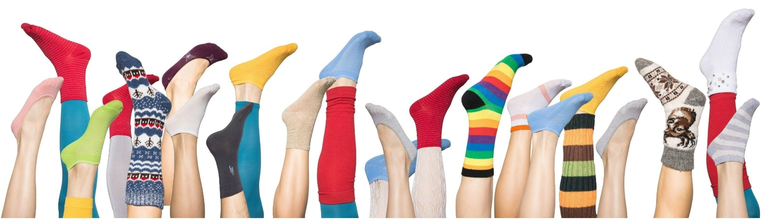www.unitedwaymc.org
705 S. 24th Ave. Suite 400B
Wausau, WI 54401
Contact: Sarah Olafson, Director of Communications
Phone: 715-298-5709
Email: solafson@unitedwaymc.org

May 9, 2022
For Immediate Release

Socks for Schools

Wausau, WI – United Way of Marathon County will be collecting new socks for school kids and families the entire month of May.

Socks are worn by every family member and an overlooked item when families’ needs are assessed. Schools have reported this is an ongoing request for students and families especially going back to school in the fall.

We will collect any and all sizes, colors, and types of socks. Single pairs of socks or large packages of socks are needed.

Socks will be distributed through United Way’s Community Closets and other agencies and programs such as Bare Necessities.

Donate socks and drop them off at the United Way office during normal business hours or at a Peoples State Bank location near you (All Marathon County Locations) or Healthfirst, 216 South 3rd Avenue, Wausau.

Online options are available and will be shipped directly to the United Way office.
Amazon:
Target List:
Walmart:

Thank you to the transformational leadership team for their great ideas in organizing this project.

###

